|  |  |  |
| --- | --- | --- |
|  | **JSPM’s**  **JAYAWANTRAO SAWANT POLYTECHNIC, Handewadi Road, Hadapsar, Pune-28**  **Department of Computer Engineering**  **Academic Year 2019-20** | **logo** |

**MICRO PROJECT**

**TITLE OF THE PROJECT**

* **Design Normalized database for Blood Bank.**

**Program :** CO **Program code:** CO3I

**Course :** Database Management System **Course code:** 22319

**Class :** SYCO1  **Group No:** Q/17

**Project Guide**: Ms.SherkhaneN.S



**MAHARASHTRA STATE BOARD OF TECHNICAL EDUCATION**

**Certificate**

This is to certify that Mr Ashish Dhananjay Kadam Semester of I Semester of Diploma in Computer Engineering of Institute Jayawantrao Sawant Polytechnic (Code: 0711) has completed the Micro Project satisfactorily in Subject Database Management System –(22319) for the academic year 2019- 2020- as prescribed in the curriculum.

Place: Hadapsar, Pune.

Enrollment No: 1807110129

Date: ……

Exam Seat No:- 214508

Subject Teacher Head of the Department Principal

* **MICRO PROJECT GROUP DETAIls**

|  |  |  |  |
| --- | --- | --- | --- |
| 21 | Ashish Dhananjay Kadam | 1807110129 | 214508 |

* **INDEX:**

|  |  |  |
| --- | --- | --- |
| **Sr No.** | **Content** | **Page No.** |
| **1** | Certificate | 1-2 |
| **2** | Group Details | 3 |
| **3** | Index | 4 |
| **4** | Annexure IA (part A) | 5 |
| **5** | Need of Database Normalization: | 6 |
| **6** | Updating Data Problem/Update Anomaly | 7 |
| **7** | Database Normalization Forms: | 8 |
| **8** | Normalization database for Blood Bank : | 13-20 |
| **9** | Annexure II A (Part B) | 21,22 |
| **10** | Annexure IV (Teachers Evaluation Sheet) | 23-31 |

|  |  |  |
| --- | --- | --- |
|  | **JSPM’s**  **JAYAWANTRAO SAWANT POLYTECHNIC, Handewadi Road, Hadapsar, Pune-28**  **Department of Computer Engineering**  **Academic Year 2019-20** | **logo** |

* **Title of Micro project:**

**1.0 Brief Introduction:** In this project, we have explained the Need of Database Normalization,how to Update Data Problem/Update Anomaly,various Database Normalization Forms and created Normalized database for Blood Bank.

**2.0** **Aim of Micro Project:** The aim of the project is to Design normalization database for blood bank.

**3.0Action Plan** (Sequence and time required for major activities for 8 week)

|  |  |  |  |  |
| --- | --- | --- | --- | --- |
| **Sr. No** | **Details of activity** | **Planned start date** | **Planned Finish date** | **Name of Responsible Team members** |
| 1 | Collecting the information of view | 14/7/2019 | 14/7/2019 | Ashish kadam |
| 2 | Sorting the information of view | 28/7/2019 | 28/7/2019 |
| 3 | Compilation of the project | 11/8/2019 | 11/8/2019 |
| 4 | Submission of the project | 7/10/2019 | 7/10/2019 |

**4.0 Resources required** (major resources such as raw material, some machining facility, software etc.)

|  |  |  |  |  |
| --- | --- | --- | --- | --- |
| **Sr. NO** | **Name of resource / material** | **Specification** | **Quantity** | **Remarks** |
| 1 | Computer System | Windows 7 ultimate | 1 |  |
| 2 | Pc | Windows 10 | 1 |  |
| 3 | Web | Chrome browser to acquire basic knowledge about computer graphics . | 1 |  |

* **Need of Database Normalization:**

If your database objects are not in structured or normalized way it is difficult to update the database without facing the database loss. Insertion, Updating and deletion are very frequent if data is not normalized. Normalization is part of successful database design. Without Database normalization the database system can be slow, Inaccurate and inefficient.

* **Real Life Example of data which is not normalized:**

Let’s take Example of Employee Table:

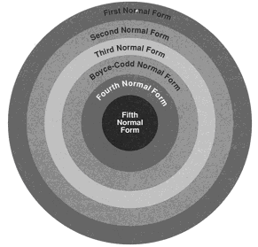

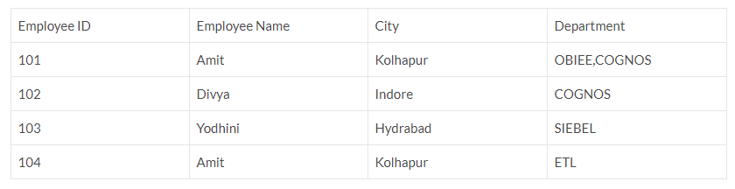

* **Updating Data Problem/Update Anomaly:**

If we want to update the city of employee who occurred twice or more than twice in the table then we need to update city of all the employees. Hence data will become inconsistent. Example is Employee named Amit is associated with two departments and the values of the departments are not atomic.

* Insertion Anomaly:

If new employee joined company and he or she has not allotted to department. Hence We need to insert null value there which leads to insertion Anomaly.

* Deletion Anomaly:

If Employee_id 101 has only 1 department and we delete that temporary then Entire student record will be deleted.

To Overcome these kind of issues there is need to use the database normalized forms. When we try to normalize database check following 4 important points:

1. Arrangement of data into logical groups.

2. Minimize the Duplicate data.

3. Organize the data in such way that when modification needed then there should be only one place modification required.

4. User can access and manipulate data quickly and efficiently.

### Database Normalization Forms:

There are following Four Normal Forms used in Database Normalization:

1. First Normal Form

2. Second Normal Form

3. Third Normal Form

4. Boyce-code Normal Form (BCNF)

### 1. First Normal Form/1st Normal Form:

The first normal form is the normal form of database where data must not contain repeating groups. The database is in First normal form If,

1. It contains only atomic values.

**Atomic values:-** The Single cell have only single value

2. Each Record needs to be unique and there are no repeating groups.

**Repeating Groups:-** Repeating group means a table contains 2 or more values of columns that are closely related.

**Example:**

Consider following table which is not normalized:

Employee Table:

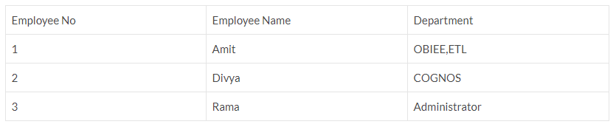

To bring it in to first normal form we need to split table into 2 tables.

First table: Employee Table:

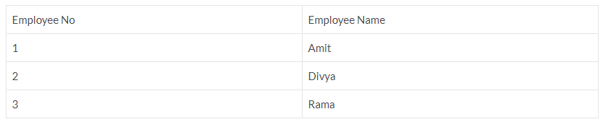

Second Table: Department table

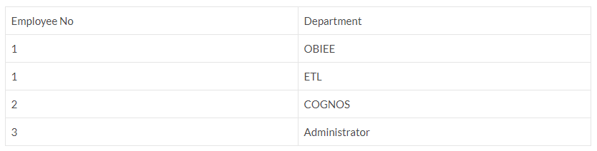

We have divided the table into two different tables and the column of each table is holding the atomic values and duplicates also removed.

### 2. Second Normal Form/2nd Normal Form:

The data is said to be in second normalized form If,

1. It is in First normal form

2. There should not be any partial dependency of any column on primary key. Means the table have concatenated primary key and each attribute in table depends on that concatenated primary key.

3. All Non-key attributes are fully functionally dependent on primary key. If primary is not composite key then all non key attributes are fully functionally dependent on primary key.

**Example:**

Let us consider following table which is in first normal form:

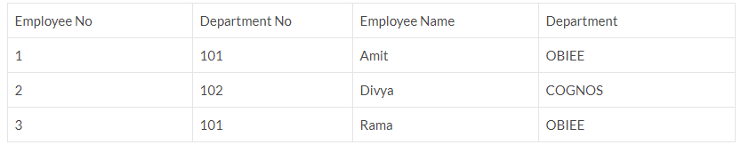

In above example we can see that department .Here We will see that there is composite key as{ Employee No, Department No}.Employee No is dependent on Employee Name and

Department is dependent on Department No. We can split the above table into 2 different tables:

Table 1:Employee_NO table:

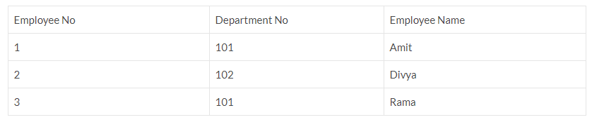

Table 2: Department table:

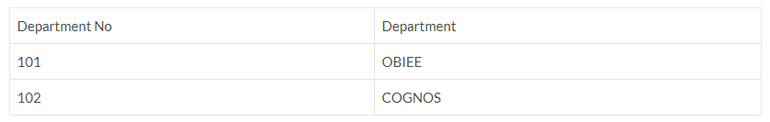

Now we have simplified the table in to second normal form where each entity of table is functionally dependent on primary key.

### 3. Third Normal Form/3rd Normal Form:

The database is in Third normal form if it satisfies following conditions:

1. It is in Second normal form

2. There is no transitive functional dependency

* **Transitive Dependency:**

When table 1 is functionally dependent on table 2. And table 2 is functionally dependent on table 3 then. Table 3 is transitively dependent on table 1 via table 2**.**

**Example:**

Consider following table:

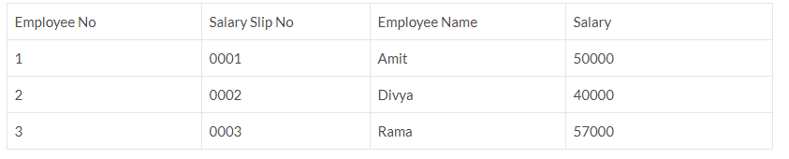

In above table Employee No determines the Salary Slip No. And Salary Slip no Determines Employee name. Therefore Employee No determines Employee Name. We have transitive functional dependency so that this structure not satisfying Third Normal Form.

For That we will Split tables into following 2 tables:

Employee table:

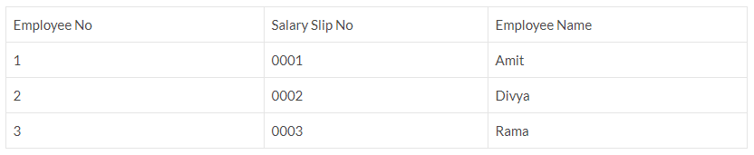

Salary Table:

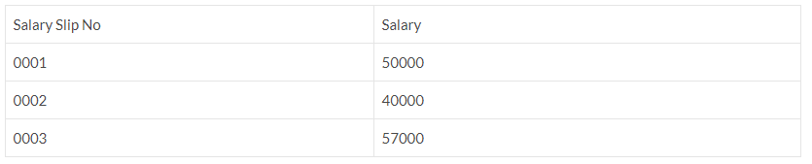

Following are 2 Advantages of 3rd normal form:

1. Amount of data duplication is removed because transitive dependency is removed in third normal form.

2. Achieved Data integrity

* Normalization database for Blood Bank :
* Table 1] create table Donor123(dName varchar(10),dId number(10),sex varchar(10),age number(10),dreg_date date,db_grp varchar(10)PH_NO NUMBER(10));

Table created.

0.02 seconds

|  |  |  |
| --- | --- | --- |
|  |  |  |

* insert all into Donor1234 values('nasif',3,'M',23,1/1/201,'A+')
* into Donor1234 values('nimi',7,'f',22,1/1/2010,'B+')
* into Donor1234 values('jenifer',10,'f',22,2/1/2010,'O+')
* into Donor1234 values('tanzima',14,'f',22,2/1/2010'A+')
* into Donor1234 values('kaniza',16,'f',22,3/1/2010,'A+')
* select 1 from dual;
* select 1 from dual;
* select * from Donor1234

5 row(s) inserted.

0.02 seconds

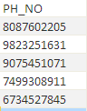

* Table 2] create table Blood_Processing_Manager (bm_id number(10), bm_name varchar(20), sex varchar(20));

Table created.

0.02 seconds

|  |  |  |
| --- | --- | --- |
|  |  |  |

* Insert all into BLOOD_PROCESSING_MANAGER (6,'Deepa','F')
* INTO BLOOD_PROCESSING_MANAGER (36,'Mehrab','M')
* INTO BLOOD_PROCESSING_MANAGER (47,'Urmi','F')
* INTO BLOOD_PROCESSING_MANAGER (47,'Urmi','F')

5 row(s) inserted.

* Select * from Blood _processing _Manager



* Table3] create table Blood_Samples1 (b_group varchar(10),sample_no number(10),status varchar(10));
* insert all into blood_samples1 values('A+',305,'no')
* into blood_samples1 values('B+',401,'no')
* into blood_samples1 values('B+',405,'no')
* into blood_samples1 values('O+',202,'no')
* into blood_samples1 values('O+',410,'no');
* select 1 from dual;

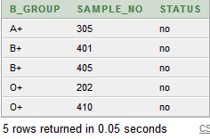

* Normalization of donor table

1NF]



2NF]



3NF]



NORMALIZATION OF BLOOD SAMPLE

1NF]

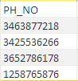

2NF]



3NF]



* Normalization of **BLOOD_PROCESSING_MANAGER**

**1NF]**

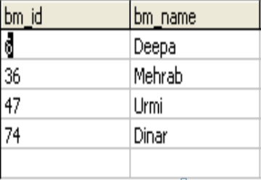

2NF]

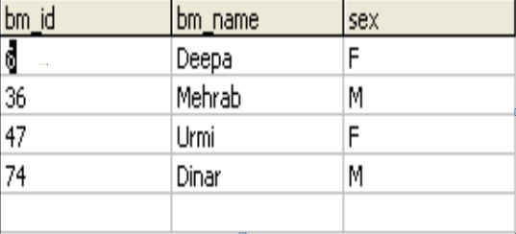

3NF]



|  |  |  |
| --- | --- | --- |
|  | **JSPM’s**  **JAYAWANTRAO SAWANT POLYTECHNIC, Handewadi Road, Hadapsar, Pune-28**  **Department of Computer Engineering**  **Academic Year 2019-20** | **logo** |

* **Title of Micro project:** Design Normalized database for Blood Bank.

**1.0 Brief Description:**  In this project, we have explained the Need of Database Normalization,how to Update Data Problem/Update Anomaly,various Database Normalization Forms and created Normalized database for Blood Bank.

**2.0 Aim of Micro Project:** The aim of the project is to Design normalization database for blood bank.

**3.0 Course Outcome Integrated :** To learn and understand the basics of Database Management system.

**4.0 Actual Procedure Followed:** 1. Created and gathered information and sorted it in order.

2.Understood the concepts and planned the dates to do it .

3.Executed the plan properly whole gaining knowledge and discipline .

**5.0 Actual Resources Used** (mention the actual resources used.)

|  |  |  |  |  |
| --- | --- | --- | --- | --- |
| **Sr. NO** | **Name of resource / material** | **Specification** | **Quantity** | **Remarks** |
| 1 | Computer System | Windows 7 ultimate. | 1 |  |
| 2 | Mobile | Samsung,lg,oppo. | 1 |  |
| 3 | Web | Chrome browser to acquire basic knowledge about Database management system | 1 |  |

**6.0 Outputs of the Micro Projects:** Thus we have studied and under stood all the basic concepts and queries of Database management system. Outputs of projects have attached at respective places.

**7.0 Skill Developed/ Learning out of this Micro project**

Throughout this project we developed some important skills like leadership quality, scheduling of the project and risk management. One of the most important skills we developed is the communication and coordination between our team members. We also learned planning skills, time management and adaptability.

* **Teacher Evaluation Sheet**
* **Name of students:** Ashish Dhananjay Kadam .
* **Enrollment No**: 1807110129
* **Name of program** Design Normalized database for Blood Bank.

* **Semester**: Third.
* **Course Title**: DATABASE MANAGEMENT SYSTEM
* **Code:** 22319
* **Title of Micro Project:** Implement banking operations like: Deposit, Withdraw and Balance Inquiry.
* **Course Outcomes Achieved:**

|  |  |
| --- | --- |
| **Course #** | **Course Outcome Statement** |
| C304 .1 | Design Normalized database on given data |
| C304 .2 | Create and manage database using SQL command |
| C304 .3 | Write PL/SQL Code for given database |
| C304 .4 | Apply Triggers to database also create procedure and function according to condition |
| C304 .5 | Apply security and confidentiality on given database. |

* **Evaluation as per suggested Rubric for Assessment of Micro Project**

|  |  |  |  |  |  |
| --- | --- | --- | --- | --- | --- |
| **Sr. No** | **Characteristic to be assessed** | **Poor**  (Marks1- 3) | **Average**  (Marks 4 -5) | **Good**  (Marks 6 -8) | **Excellent**  (Marks 9 - 10) |
| 1 | Relevance to the course |  |  |  |  |
| 2 | Literature Survey / Information collection |  |  |  |  |
| 3 | Project Proposal |  |  |  |  |
| 4 | Completion of the Target as per Project Proposal |  |  |  |  |
| 5 | Analysis of data and representation |  |  |  |  |
| 6 | Quality of Prototype/ Model |  |  |  |  |
| 7 | Report preparation |  |  |  |  |
| 8 | Presentation |  |  |  |  |
| 9 | Defense |  |  |  |  |

* **Micro Project Evaluation Sheet**

|  |  |  |  |  |
| --- | --- | --- | --- | --- |
| **Process Assessment** | | **Product Assessment** | | **Total Marks**  **10** |
| **Part A - Project Proposal**  **(2 Marks)** | **Project Methodology**  **(2 Marks)** | **Par B - Project Report/ working Model**  **(2 Marks)** | **Individual Presentation/ Viva**  **(4 Marks)** |
|  |  |  |  |  |

**Note: Every course teacher is expected to assign marks for group evaluation in first 3 columns and individual evaluation 4th column**

**Comment/ suggestion about team work/leadership/ interpersonal communication (If any)**

………………………………………………………………………………………………………………………………………………………………………………………………………………………………………………………………………………………………………………………………………………………………………………………………………………………………………………………………………

………………………………………………………………………………………………………………………………………………………

**Any other comment:**

………………………………………………………………………………………………………………………………………………………………………………………………………………………………………………………………………………………………………………………………………………………………………………………………………………………………………………………………………

**Name and Designation of the Faculty Member: MS.SHERKHANE N.S**

**Signature: …………………………**